Portfolio Financial Data

Overview
This dashboard is designed to showcase my data analysis skills. The data used here are fictitious and solely for demonstration purposes. This dashboard highlights my capability. In this Dashboard is presented connection with Local Database via SSMS , API from(GitHub) with Json data and excel file with FX rates to recalculate foreign currency to USD used as common currency.

Data Modeling
We are utilizing 3 sources:
Database (Local Host)
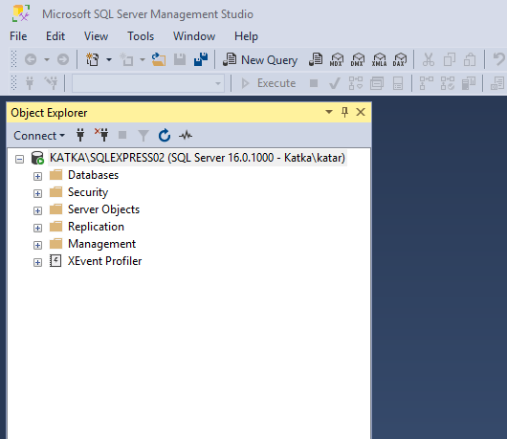

API (GithHub)Json Data
Link:
https://kate13122.github.io/Project-Mondel/Final_Clients_Data.json
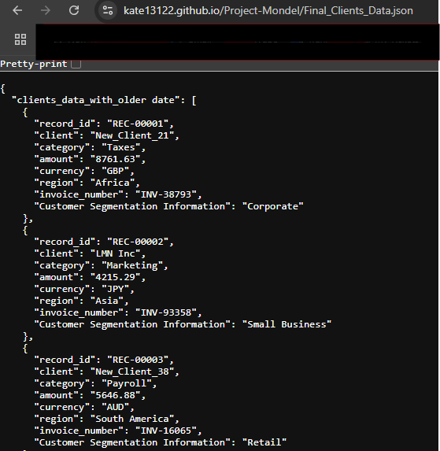

Excel File (sheet FX rates)

LastRefreshed Date: Use a formula to track when the data was last refreshed.

Data Modeling:
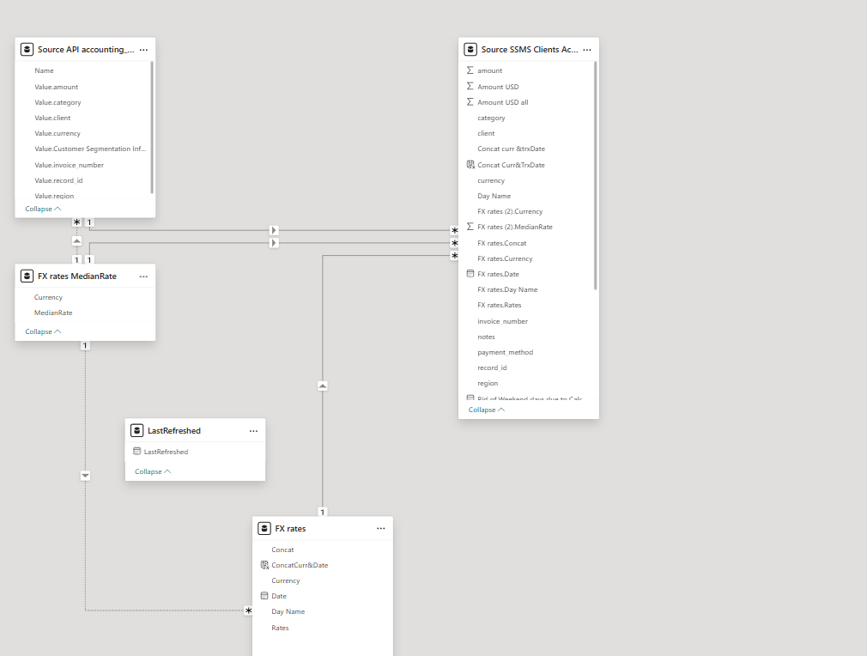

Backend Key Changes to get results as expected:
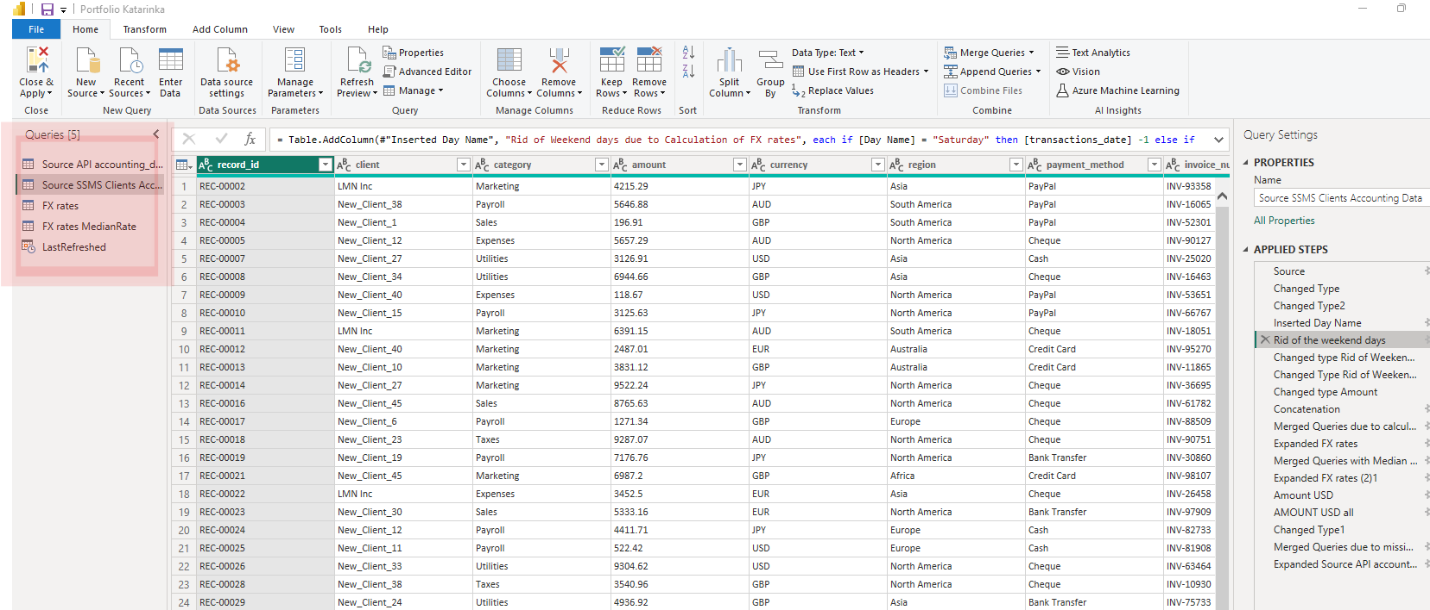
Formula to rid of the weekend dates as FX rates are not calculated during weekends
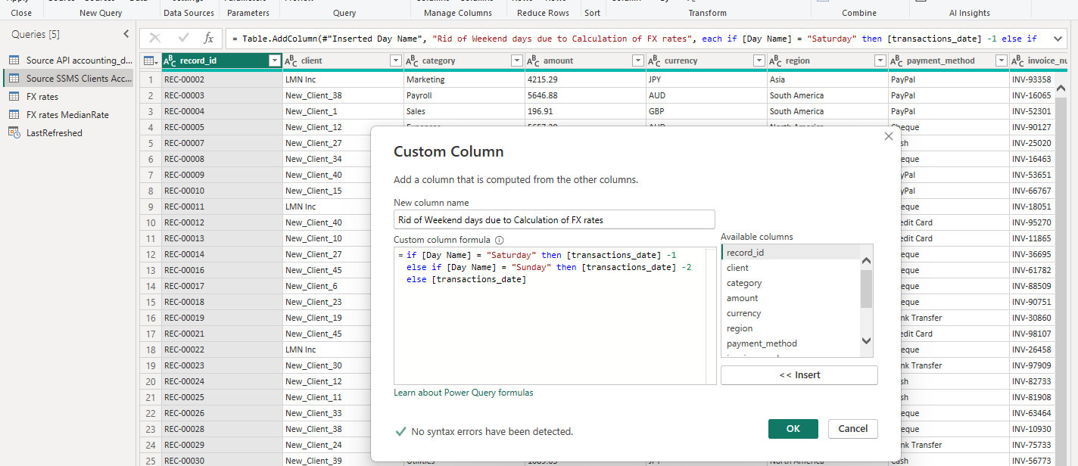

Concatenation to get unique vales
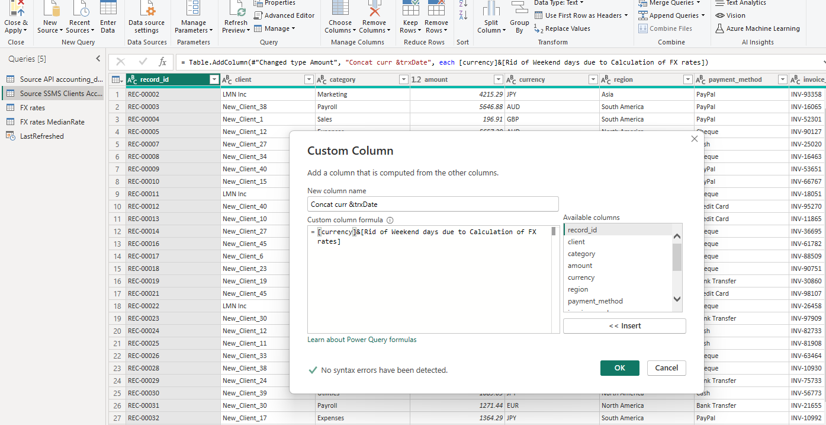

Merge queries to assign correct Rate:
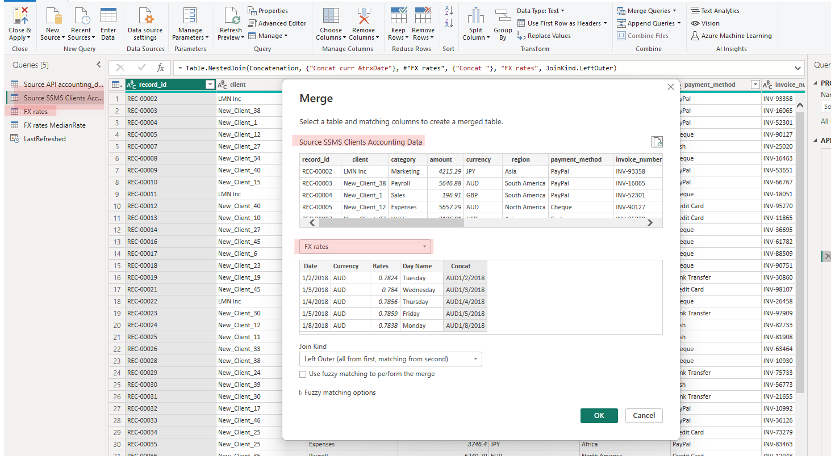

As we missed some of the dates and due to this rates were not calculated

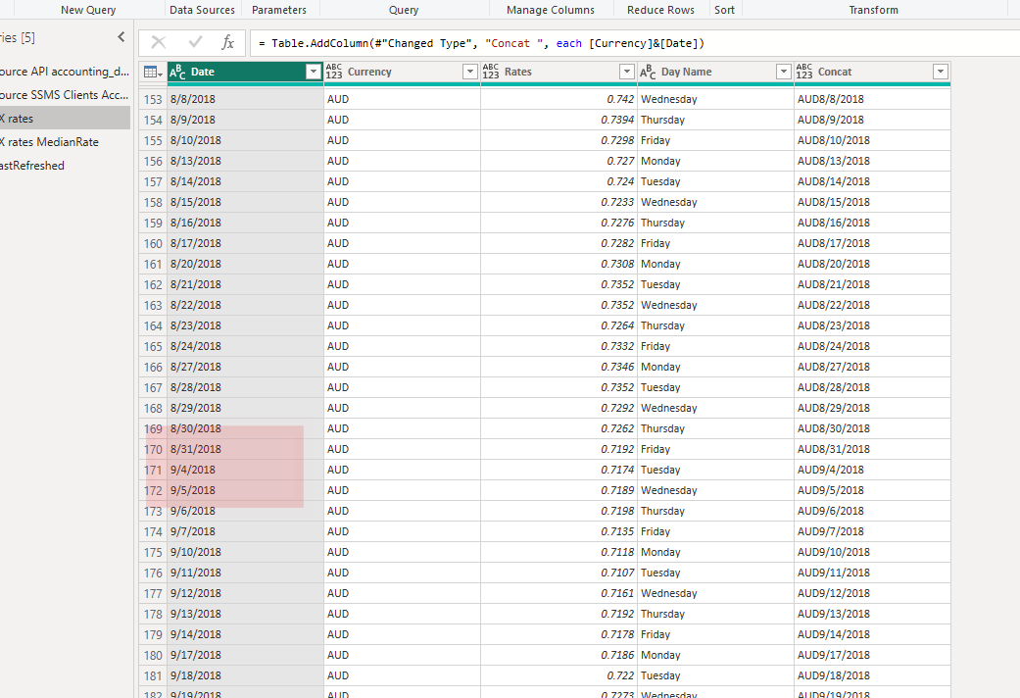

- I created copy of the FX rates table to calculate median for conversion to USD for those where we missed rates.
- 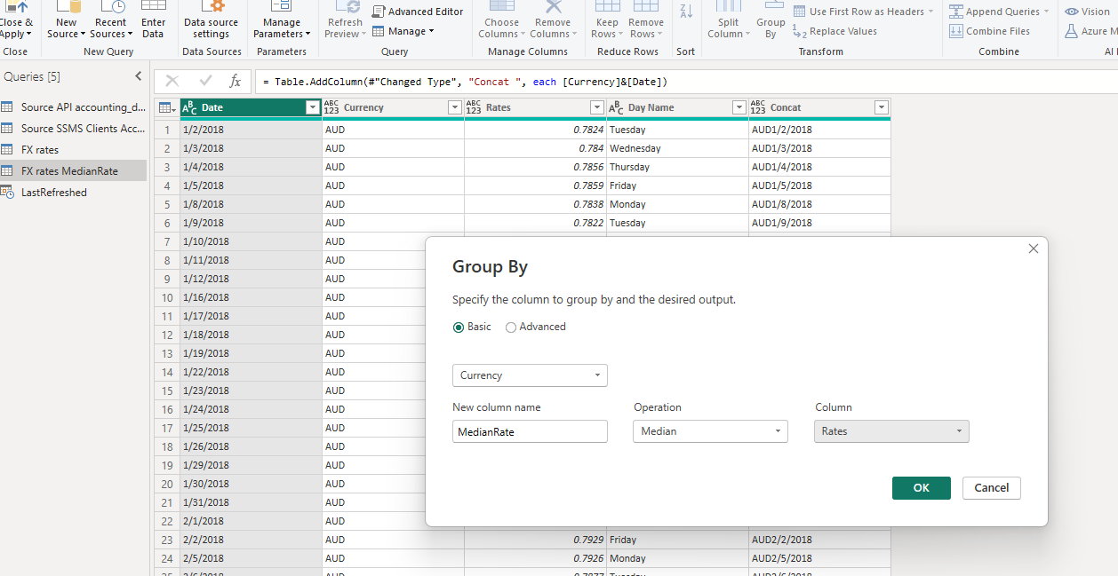
Conversion to USD

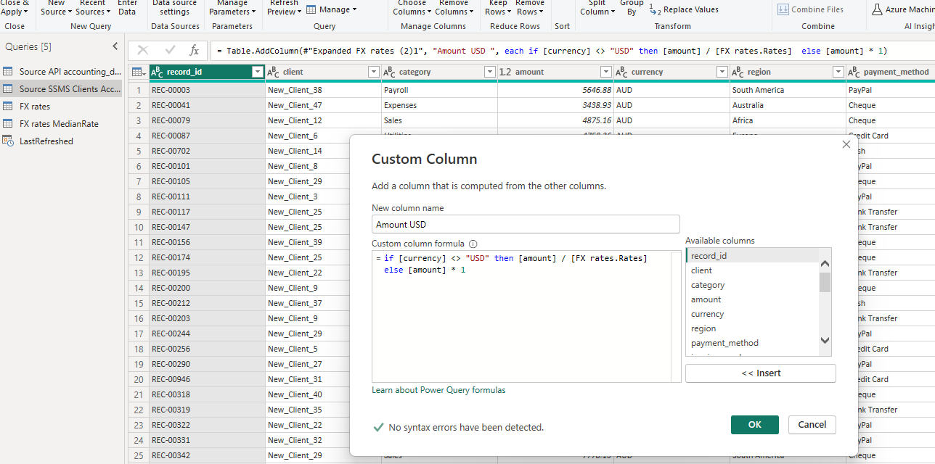

Those what are missing dates are using Median Rate
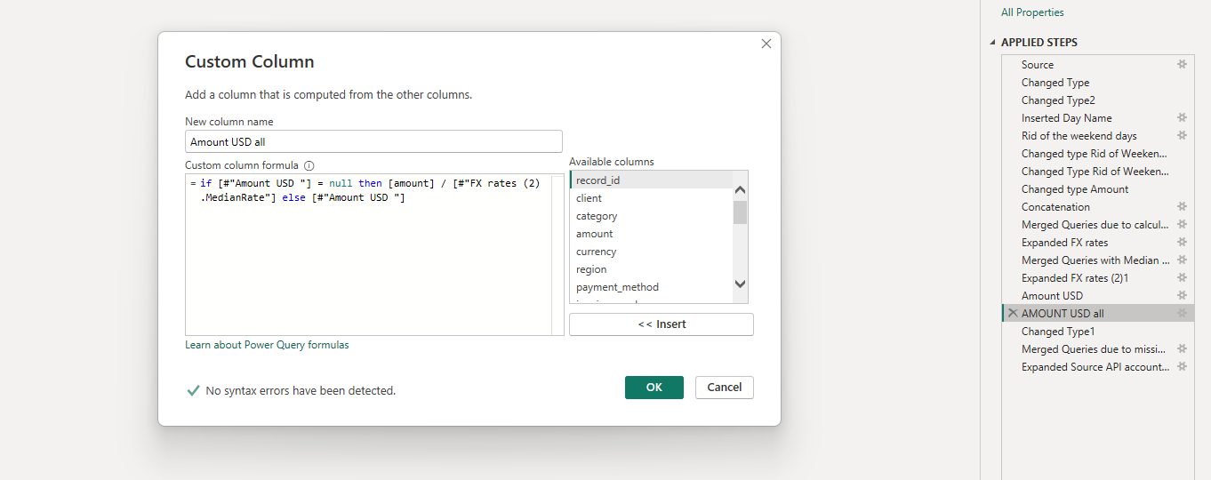

Using DAX to split among regions for usage in Frontend.

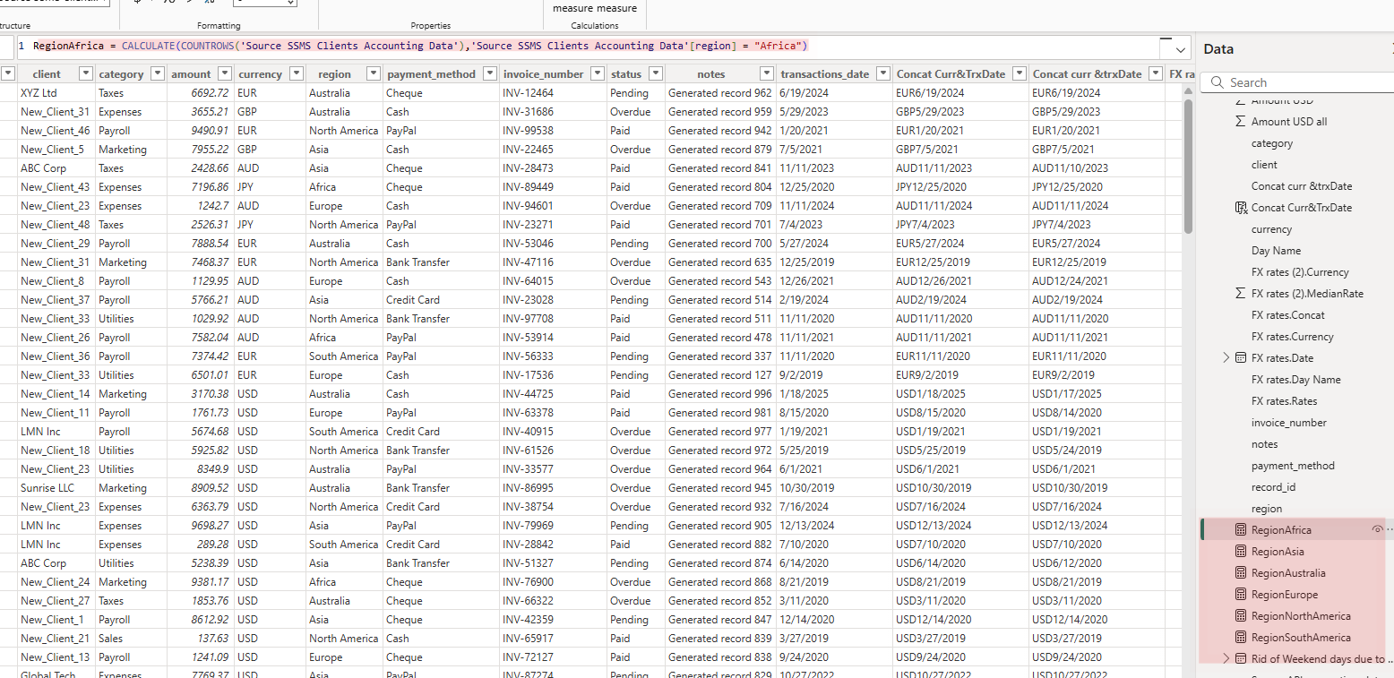

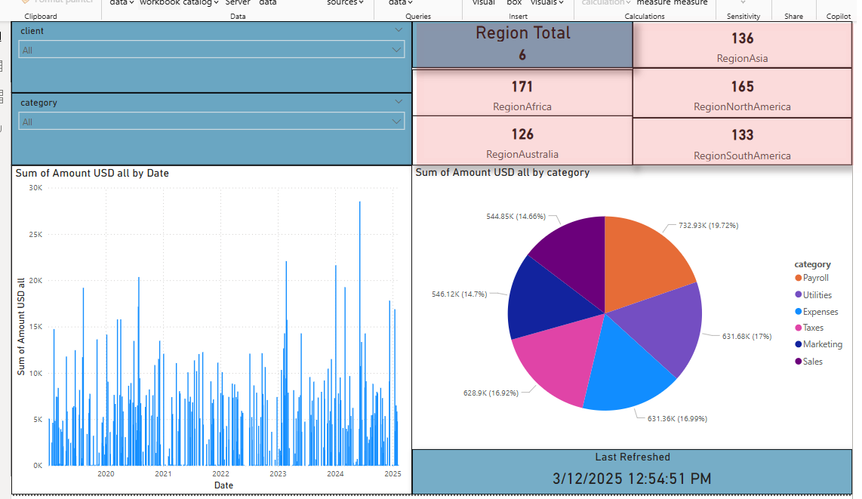

Some visualizations as example:

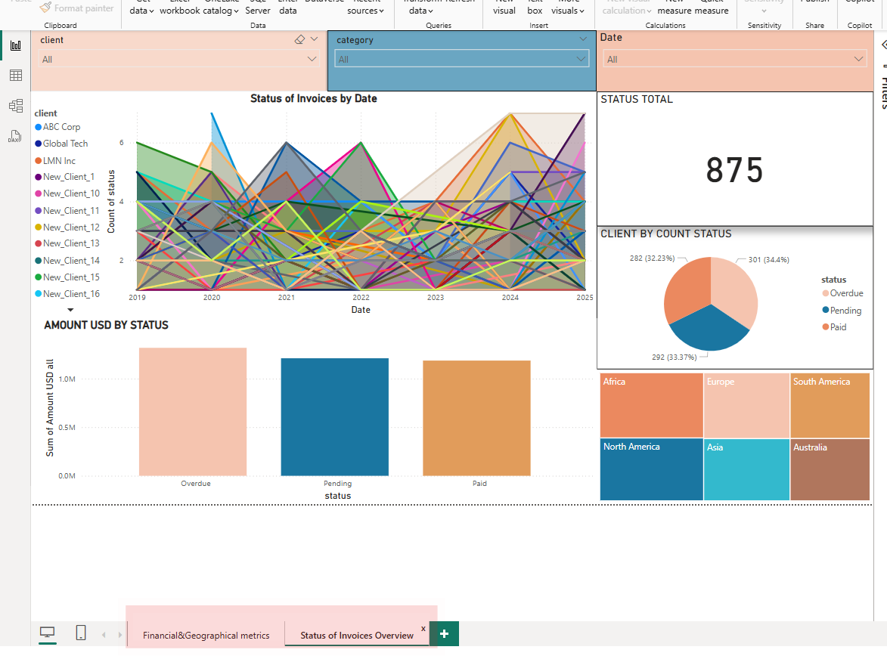

Portfolio Property Data
Overview:
This dashboard is designed to showcase my data analysis skills. The data used here are fictitious and solely for demonstration purposes.
DAX queries:

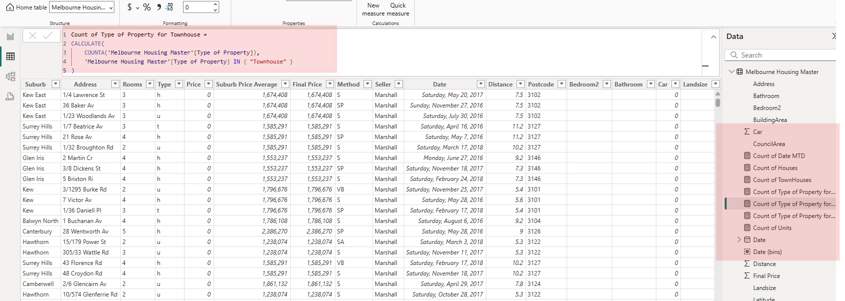

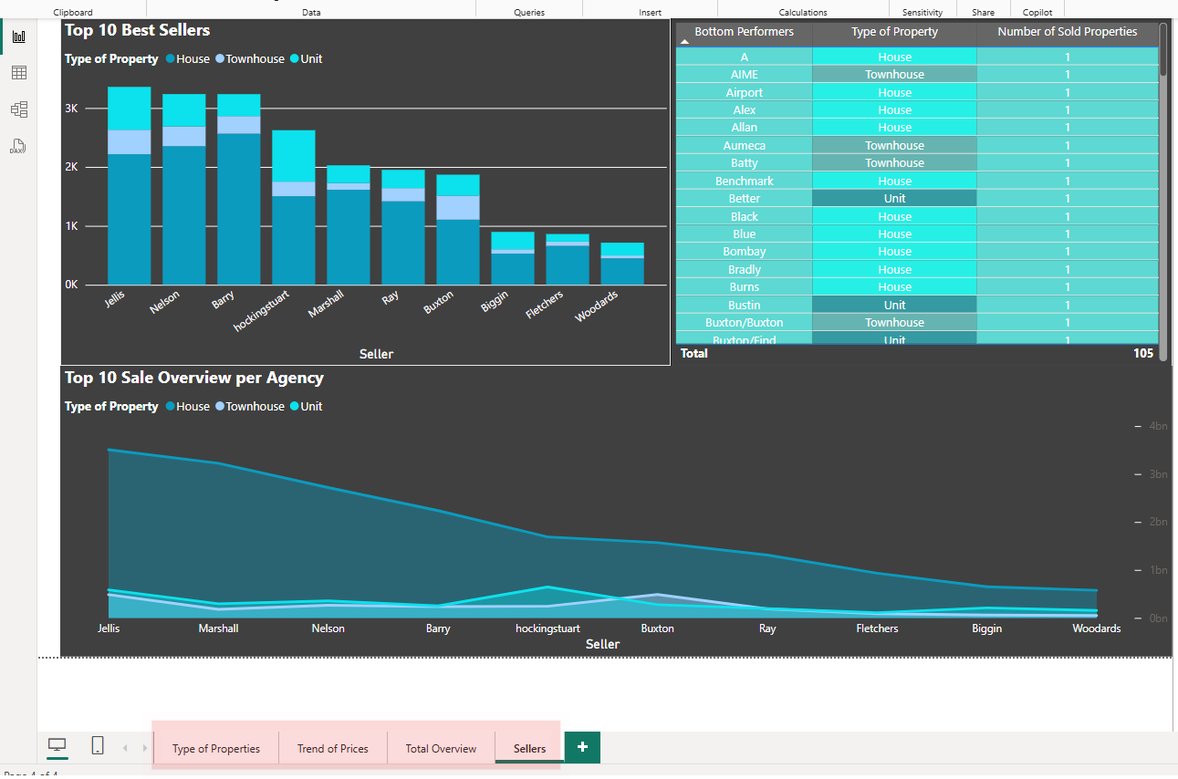

Portfolio google sheets

https://docs.google.com/spreadsheets/d/1aoo1puIkijPvvKmepjOHtVsWbDEJ3ldeik8LxuRNoRI/edit?gid=1466163780#gid=1466163780&fvid=1719402450

